**Student: Rafael Santos** (please note solution comments for other items towards the bottom of this report)

**Assignment:**

Create a report in Microsoft Word and answer the following questions…

1. What are three conclusions we can make about Kickstarter campaigns given the provided data?

2. What are some of the limitations of this dataset?

3. What are some other possible tables/graphs that we could create?

**Answers:**

**1. What are three conclusions we can make about Kickstarter campaigns given the provided data?**

A) Majority of the campaigns (2833 or 68.9%) were art-related projects (theater, music, film & video, photography), followed by technology (600 or 14.6%), publishing (237 or 5.8%), games (220, or 5.3%), and food (200 or 4,9%). However, technology campaigns represent 50.7% of total amount pledged during the period against 37.2% pledged on the art-related projects.

B) 53.1% of the overall campaigns were successful, representing 87.9% of the pledges. Conversely, the category theater with the highest successful rate of 20.4% represents only 11,1% of the pledges on successful campaigns. Technology accounts for 42.6% of the pledge amounts on successful campaigns, which represents only 5.1% of the campaigns.

*For A and B - See the original for this Pivot Table supporting the answers in the sheet Category Stats @ A23:U37*

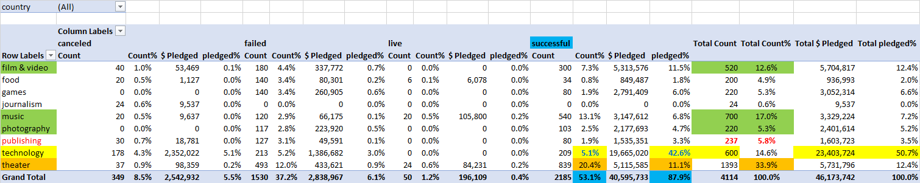

C) Historically, May is the month with highest number of successful campaigns, while December is the month with the least successful campaigns (possibly influenced by the end-of-year holidays). However, October has the highest number of failed projects, followed by January and both June and July on third place.

***Source: Pivot Table on “Outcomes Based On Launch Date” sheet.***

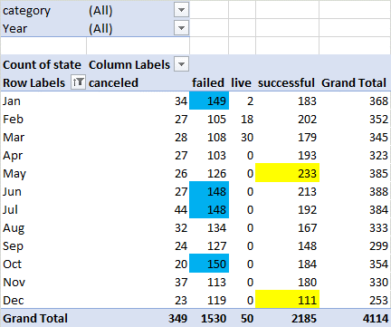

**2. What are some of the limitations of this dataset?**

Some limitations with this dataset are:

* We cannot determine the demographics of donators (e.g. age, gender, region/location, language)
* We cannot determine details on user pledges (e.g. how many times and to what projects users pledge)
* We do not have consolidated data to determine in which language the campaign was made.
* We do not know if the amounts listed are all in USD or represented in multiple currencies.

**3. What are some other possible tables/graphs that we could create?**

Some of the visual analysis we could create with graphs are:

- duration of project vs outcome.

- duration of the project vs number of pledges.

- number of pledges by goal ranges and outcome.

- monthly ratio of pledges (# and $) per number of active projects.

- influence of the number of campaigns per month (# and $) on thesuccess rates, filtered by categories/subcategories.

**SOLUTION COMMENTS FOR OTHER ITENS ON THIS ASSIGNMENT**

KICKSTARTER TABLE

* Use conditional formatting to fill each cell in the state column with a different color, depending on whether the associated campaign was "successful," "failed," "cancelled," or is currently "live".

|  |  |  |  |  |  |  |
| --- | --- | --- | --- | --- | --- | --- |
| RS:  Below is the summary of colors   |  | | --- | | **validation summary** | | successful | | canceled | | failed | | live |   and the validation rule detail on the right |  |

* Create a new column at column O called percent funded that uses a formula to uncover how much money a campaign made towards reaching its initial goal.
  + Use conditional formatting to fill each cell in the percent funded column using a three-color scale. The scale should start at 0 and be a dark shade of red, transitioning to green at 100, and then moving towards blue at 200.

RS: See rule below

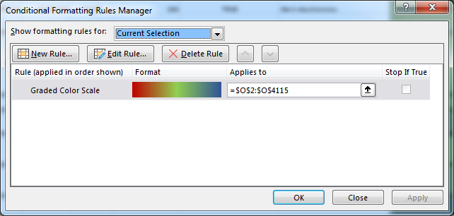

* Create a new column at column P called average donation that uses a formula to uncover how much each backer for the project paid on average.

RS: Because some projects did not have backers, I created a formula to show “0” instead of an #error due to the division of total donated by 0.

* Create two new columns, one called category at Q and another called sub-category at R, which use formulas to split the Category and Sub-Category column into two parts.

RS: I created a combination of TEXT-type formulas to split the text in two new columns Q and R.

CATEGORY STATS

* Create a new sheet with a pivot table that will analyze your initial worksheet to count how many campaigns w ere "successful," "failed," "cancelled," or are currently "live" per category.
* Create a stacked column pivot chart that can be filtered by country based on the table you have created.

RS: see pivot table and pivot chart in the sheet **Category Stats**.

Note that I added an option to filter by Country using the feature Slicer.

SUBCATEGORY STATS

* Create a new sheet with a pivot table that will analyze your initial sheet to count how many campaigns w ere "successful," "failed," "cancelled," or are currently "live" per sub-category.
* Create a stacked column pivot chart that can be filtered by country and parent-category based on the table you have created.

RS: see pivot table and pivot chart in the sheet **Subcategory Stats**.

**Parent-category is** a Field header named just as **Category**

Note that I added an option to filter by Country and [Parent] Category using the feature Slicer.

* The dates stored within the deadline and launched at columns are using unix timestamps. Fortunately for us, there is a formula out there that can be used to convert these timestamps into a normal date.
  + Create a new column named Date Created Conversion that will use this formula to convert the data contained within launched_at into Excel's Date format

RS: Date Created Conversion is in column S of sheet Kickstarter Table.

Because I was not aware of the ability to Group by Date from the Pivot Table, in this case I created a complex combination of formulas to identify YEAR, MONTH, DAY and individually combine (CONCATENATE) then as “text”, and finally convert the “text” into a numeric value equivalent to date.

* + Create a new column named Date Ended Conversion that will use this formula to convert the data contained within deadline into Excel's Date format

RS: Date Ended Conversion is in column T of sheet Kickstarter Table.

OUTCOMES BASED ON LAUNCH DATE

* Create a new sheet with a pivot table with a column of state, rows of Date Created Conversion, values based on the count of state, and filters based on parent category and Years.

RS: Created the sheet **Outcomes Based on Launch Date**. Note that I grouped the Date Created Conversion field by Months.

* Now create a pivot chart line graph that visualizes this new table.

RS: See in the sheet **Outcomes Based on Launch Date**. Note that slicer filters were added.